**The Importance of** [**Digital Logistics Companies**](https://zipaworld.com/Home) **in India**

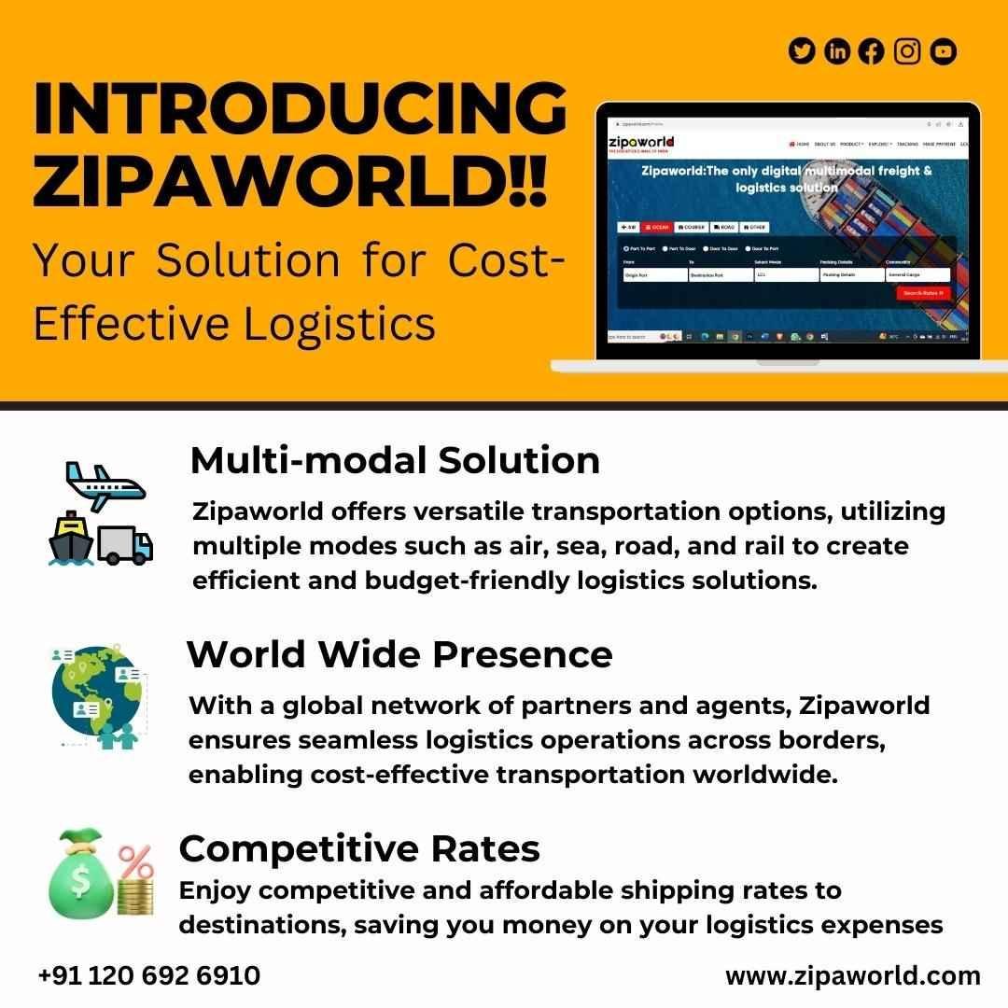

In the dynamic and fast-paced world of international trade, [**digital logistics company**](https://zipaworld.com/Home) plays a pivotal role in ensuring the smooth movement of goods and services across borders. India, being one of the fastest-growing economies, relies heavily on the efficient functioning of its logistics sector. A robust logistics network is crucial for the country's economic growth, seamless supply chain operations, and overall development.

**Use of** [**Freight Forwarding**](https://zipaworld.com/Home) **in India**

Freight forwarding serves as a cornerstone of the logistics industry, acting as a bridge between exporters, importers, and transportation services. In India, freight forwarding has gained significant traction due to the country's expanding trade relations with the global market. Freight forwarders play a pivotal role in coordinating the complex web of activities involved in international shipping, including documentation, customs clearance, cargo consolidation, and last-mile delivery.

**Who are** [**Freight Forwarders**](https://zipaworld.com/Home)**?**

**Freight forwarders** are intermediary entities that specialize in managing the logistics and transportation of goods from one location to another, typically across international borders. These professionals are experts in navigating the complexities of global trade and ensuring that shipments reach their destination on time and in a cost-effective manner. Freight forwarders collaborate with various carriers, such as airlines, ocean liners, and trucking companies, to negotiate competitive rates and offer diverse transportation options to their clients.

**The Future of Zipaworld as a** [**Digital Logistics Company**](https://zipaworld.com/Home)

In the era of digitization and technological advancements, traditional logistics processes are undergoing a transformation. Zipaworld, a pioneering [**digital logistics**](https://zipaworld.com/Home) company, has emerged as a frontrunner in revolutionizing the logistics landscape in India. Leveraging cutting-edge technology and innovative solutions, Zipaworld is poised to reshape the industry and drive it toward a more efficient and customer-centric approach.

The key to Zipaworld's success lies in its ability to integrate the entire logistics ecosystem onto a single digital platform. By doing so, the company eliminates inefficiencies, reduces paperwork, and enhances transparency in the supply chain. From real-time shipment tracking and instant documentation to seamless communication between stakeholders, Zipaworld streamlines logistics operations like never before.

Moreover, Zipaworld's platform empowers businesses with data-driven insights, enabling them to make informed decisions and optimize their supply chain strategies. With advanced analytics and predictive modeling, Zipaworld helps companies anticipate demand patterns, identify potential bottlenecks, and optimize routes, leading to cost savings and improved customer satisfaction.

One of the most significant advantages of Zipaworld's digital logistics approach is its eco-friendly nature. By minimizing the reliance on physical paperwork and optimizing transportation routes, the company contributes to reducing its carbon footprint, aligning with India's commitment to sustainable development.

In the coming years, Zipaworld is set to disrupt traditional logistics practices further. As it continues to expand its service offerings and global reach, the company will play a vital role in facilitating India's integration into the global supply chain. Small and medium-sized enterprises (SMEs) stand to benefit immensely from Zipaworld's accessible and affordable logistics solutions, enabling them to compete on a global scale.

In conclusion, [**digital logistics company**](https://zipaworld.com/Home) in India plays a crucial role in facilitating trade and economic growth. **Freight forwarding services** act as the backbone of this sector, ensuring seamless movement of goods across borders. As the industry embraces digital transformation, companies like Zipaworld lead the way by offering innovative, technology-driven logistics solutions.

With its commitment to efficiency, sustainability, and customer-centricity, Zipaworld is poised to shape the future of the best and most trusted [**Logistics Company**](https://zipaworld.com/Home) in India and beyond. As businesses increasingly embrace digital logistics, the industry will witness enhanced operational efficiency, reduced costs, and accelerated growth, firmly establishing India as a global logistics powerhouse.

**Zipaworld Innovation Pvt. Ltd.**

[**https://zipaworld.com**](https://zipaworld.com)

[**info@zipaworld.com**](mailto:info@zipaworld.com)

**+91 1206916910**